**Project Flow Chart:**

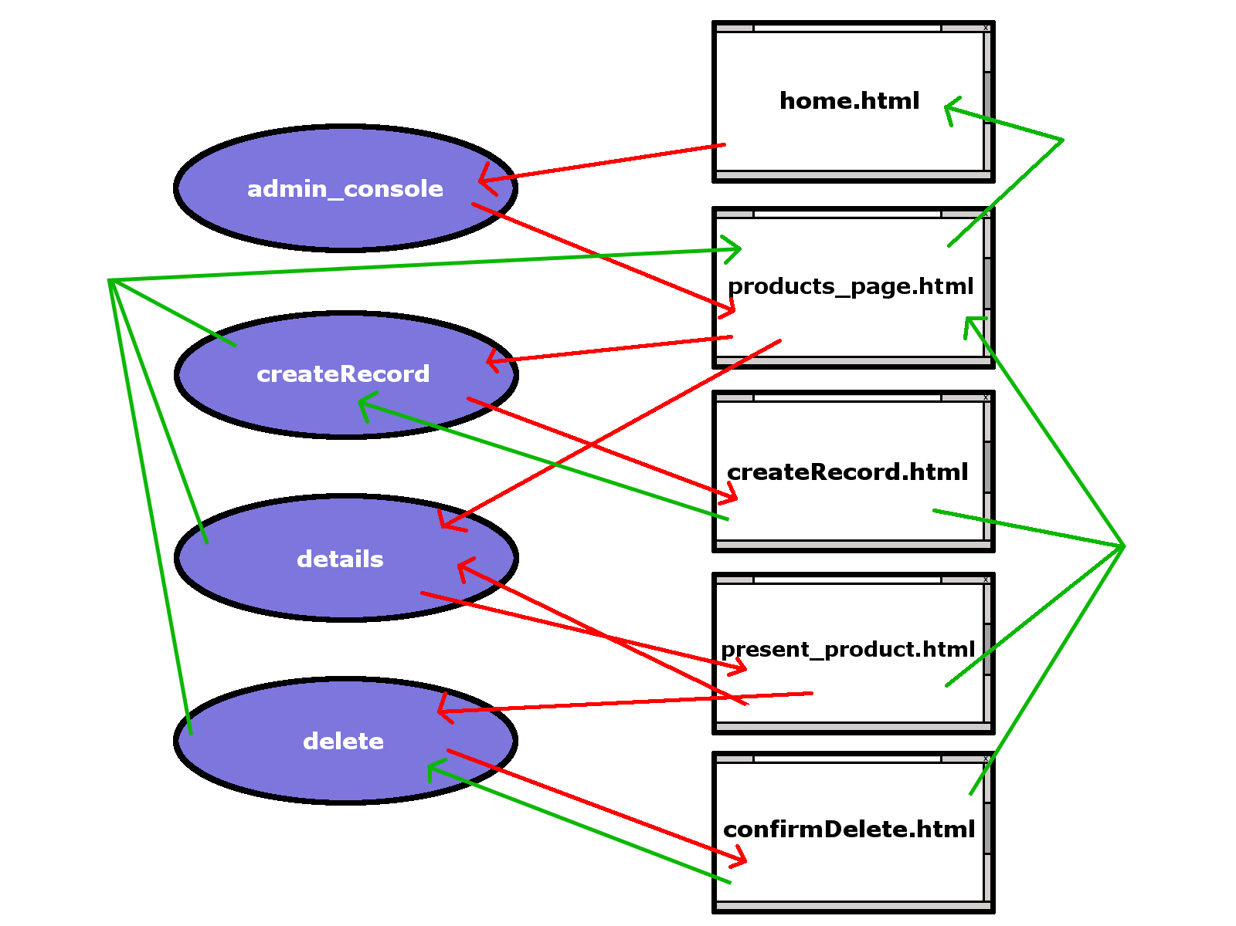

This flow chart shows our project's methods as the purple ovals and all of our views (web-pages) as the rectangles.

The red lines represent where our project will either call a particular method from our project or where one of our views (web-pages) is being dynamically populated with content by one of our methods.

The green lines represent where either one of our methods or views (web-pages) are redirecting the program flow or returning information back to a previous method or view.

Though this information may not be very helpful at this point in time, please don't forget to refer back to this Flow Chart later on if you you get confused during the series.